Guidelines for annotating signaling receptor activity

Receptor activation by a ligand is represented differently in GO-CAM depending on whether the ligand is (i) a protein (i. e., encoded by a gene) or (ii) a small molecule.

# Pathway Editor

## 

## Protein ligand-activated signaling receptor

### Ligand

The activity unit for a ligand of a signaling receptor is:

* **MF**: a ligand 'enables' receptor ligand activity ([GO:0048018](https://www.ebi.ac.uk/QuickGO/term/GO:0048018)) or a child
* **Context:** 
  + The relation between a ligand and its target receptor is *'*has input'
  + **BP** 'part of' the process in which the ligand participates, usually a child of signal transduction ([GO:0007165](https://www.ebi.ac.uk/QuickGO/term/GO:0007165))
  + **CC:**
    - extracellular ligands:'occurs in' extracellular space ([GO:0005615](https://www.ebi.ac.uk/QuickGO/term/GO:0005886))
    - membrane-bound ligands: 'occurs in' plasma membrane ([GO:0005886](https://www.ebi.ac.uk/QuickGO/term/GO:0005886))
  + The causal relation between the **ligand activity** and the **receptor activity** is   
    'directly positively regulates'.

### Signaling receptor

The activity unit for a signaling receptor is:

* **MF:** 'enables' signaling receptor activity ([GO:0038023](https://www.ebi.ac.uk/QuickGO/term/GO:0038023)*)* or a child*.*
* **Context:** 
  + The input (target) of the receptor is the **effector protein it regulates**, for example a molecular adaptor, captured with the *'*has input' relation.
  + **Note that the input (target) of the receptor is NOT its ligand**
* **BP** 'part of' the same BP/signal transduction pathway as the ligand
* **CC:** transmembrane receptors: 'occurs in' plasma membrane ([GO:0005886](https://www.ebi.ac.uk/QuickGO/term/GO:0005886))
  + The causal relation between the MF of the **receptor** and the MF of its **target** is 'directly positively regulates'*.*

**Example:** [**Insulin signaling model**](http://noctua.geneontology.org/workbench/noctua-visual-pathway-editor/?model_id=gomodel%3A6482692800000931)

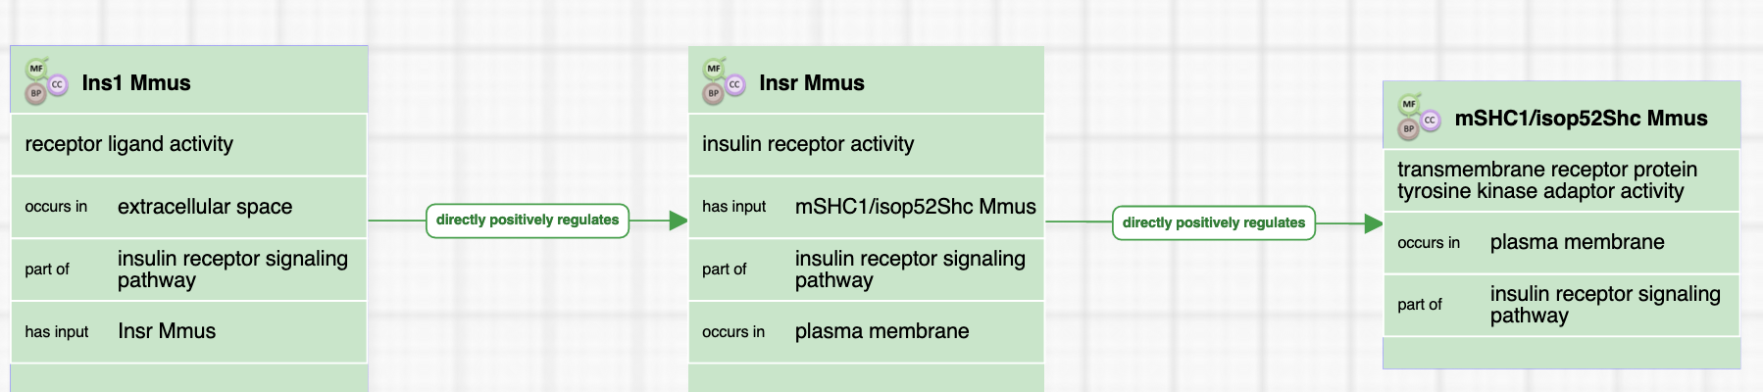

## 

## 

## 

## 

## Small molecule-activated signaling receptor activity

* Since small molecules are not annotated in GO, a small molecule ligand does not have a molecular function. Instead, the **ligand** and the **receptor activity** are linked by the causal relation 'is small molecule activator'*.*
* The receptor's function, input, and contextual relations are the same as for protein ligand-activated receptors.
* Note that it is also possible to annotate an inhibitory ligand using the relation 'is small molecule inhibitor'*.*
* BP and CC annotations are the same as for protein ligand-activated receptor activity.

**Example:** [**Activation of a GPCR by succinate**](http://noctua.geneontology.org/workbench/noctua-visual-pathway-editor/?model_id=gomodel%3A648d0dc100000022)

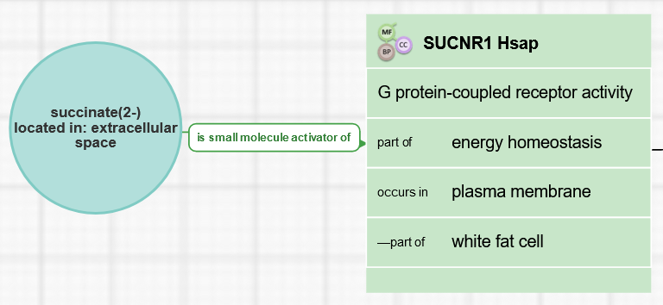

## 

## Special cases

### 

### Receptor with coreceptor

This is common in immune receptors. The typical sequence of events is that the ligand binds the signaling receptor, which signals to the co-receptor to activate its downstream effector (such as a protein kinase).

**Example:** [**IL2 signaling pathway (Human)**](http://noctua.geneontology.org/workbench/noctua-visual-pathway-editor/?model_id=gomodel:6205c24300001663)

In this case, the receptor is activated by an information biomacromolecule (i.e. a protein). Interleukin-2 ([IL2](https://www.uniprot.org/uniprot/P60568)), a cytokine, activates its receptor, interleukin-2 receptor A ([IL2RA](https://www.uniprot.org/uniprot/P01589)).

IL2RA directly positively regulates (activates) [IL2RB](https://www.uniprot.org/uniprot/P14784), which phosphorylates and positively regulates [JAK1](https://www.uniprot.org/uniprotkb/P23458).

The activity unit for a signaling coreceptor is:

* **MF:** coreceptor activity ([GO:0015026](https://www.ebi.ac.uk/QuickGO/term/GO:0015026)*)*
* **Context:** 
  + The relation between the receptor and its input (target) is the **signaling coreceptor** it regulates, captured with the *'*has input' relation
  + **Note that the input (target) of the coreceptor is NOT the ligand**
* **BP** 'part of' the BP in which the signaling receptor is involved, usually a child of signal transduction ([GO:0007165](https://www.ebi.ac.uk/QuickGO/term/GO:0007165))
* **CC:** transmembrane receptors: 'occurs in' plasma membrane ([GO:0005886](https://www.ebi.ac.uk/QuickGO/term/GO:0005886))
  + The causal relation between the MF of the **receptor** and the MF of its **coreceptor** is 'directly positively regulates'*.*

Note:

* cytokine activity is_a receptor ligand activity
* interleukin-2 receptor activity is_a signaling receptor activity

### 

### 

# 

# Form Editor

## Protein ligand-activated signaling receptor

### Ligand activity

The activity unit for a ligand of a signaling receptor is:

* **MF**: a ligand 'enables' receptor ligand activity ([GO:0048018](https://www.ebi.ac.uk/QuickGO/term/GO:0048018)) or a child
* **Context:** 
  + The relation between a ligand and its target receptor is *'*has input'
  + **BP** 'part of' the BP in which this ligand is involved (usually a child of signal transduction ([GO:0007165](https://www.ebi.ac.uk/QuickGO/term/GO:0007165)))
  + **CC:**
    - extracellular ligands: 'occurs in' extracellular space ([GO:0005615](https://www.ebi.ac.uk/QuickGO/term/GO:0005886))
    - membrane-bound ligands: 'occurs in' plasma membrane ([GO:0005886](https://www.ebi.ac.uk/QuickGO/term/GO:0005886))
* The causal relation between the ***ligand* *activity*** and the ***receptor activity*** is   
  'directly positively regulates'.

**Example:** [**Insulin signaling model**](http://noctua.geneontology.org/workbench/noctua-form/?model_id=gomodel%3A6482692800000931)

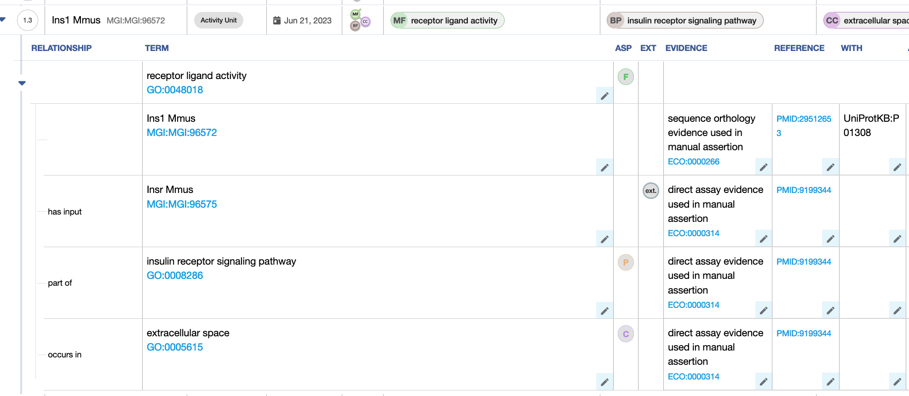

### Signaling receptor activity

The activity unit for a signaling receptor is:

* **MF:** The receptor 'enables' signaling receptor activity ([GO:0038023](https://www.ebi.ac.uk/QuickGO/term/GO:0038023)*)* or a child*.*
* **Context:** 
  + The input (target) of the receptor is the **effector protein it regulates**, for example a molecular adaptor, captured with the *'*has input' relation
  + **Note that the input (target) of the receptor is NOT its ligand**
* **BP** in which the signaling receptor is involved, usually a child of signal transduction ([GO:0007165](https://www.ebi.ac.uk/QuickGO/term/GO:0007165))
* **CC:** 'occurs in' a child of cellular anatomical entity (GO:0110165). For transmembrane receptors, annotate to plasma membrane ([GO:0005886](https://www.ebi.ac.uk/QuickGO/term/GO:0005886))

**Example:** [**Insulin signaling model**](http://noctua.geneontology.org/workbench/noctua-form/?model_id=gomodel%3A6482692800000931)

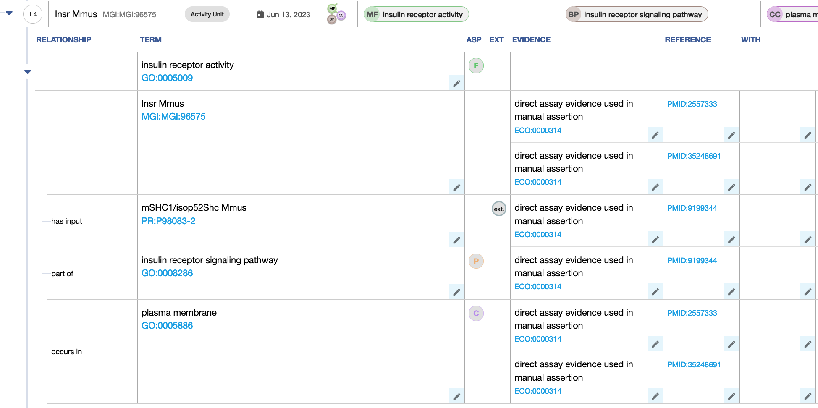

* + The causal relation between the MF of the **receptor** and the MF of its **target** is 'directly positively regulates'*.*

## 

## Small molecule-activated signaling receptor activity

* In the Form, small molecules are not captured, so the MF for the receptor. Therefore, the MF is 'enables' signaling receptor activity ([GO:0038023](https://www.ebi.ac.uk/QuickGO/term/GO:0038023)*)* or a child*.*
* BP and CC annotations are the same as for protein ligand-activated receptor activity.

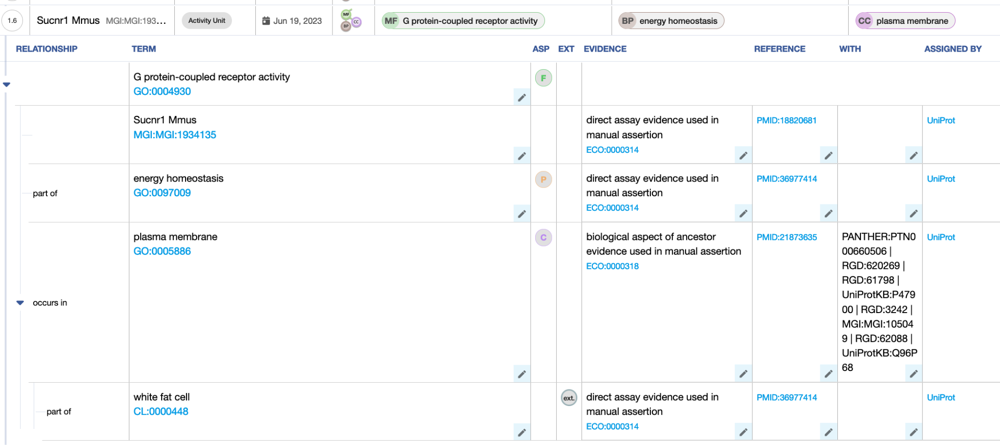

## 

## Receptor with coreceptor

### 

**Example:** [**IL2 signaling pathway (Human)**](http://noctua.geneontology.org/workbench/noctua-form/?model_id=gomodel%3A6205c24300001663)

In this case, the receptor, interleukin-2 receptor A ([IL2RA](https://www.uniprot.org/uniprot/P01589)), is activated by a protein ligand, interleukin-2 ([IL2](https://www.uniprot.org/uniprot/P60568)). IL2RA directly positively regulates (activates) the coreceptor [IL2RB](https://www.uniprot.org/uniprot/P14784), which phosphorylates and positively regulates [JAK1](https://www.uniprot.org/uniprotkb/P23458).

The activity unit for a signaling coreceptor is:

* **MF:** The coreceptor 'enables' coreceptor activity ([GO:0015026](https://www.ebi.ac.uk/QuickGO/term/GO:0015026)*)* or a child*.*
* **Context:** 
  + The input (target) of the coreceptor is the **signaling receptor** it regulates, captured with the *'*has input' relation
  + **Note that the input (target) of the coreceptor is NOT the ligand**
* **BP** 'part of' the BP in which the signaling receptor is involved, usually a child of signal transduction ([GO:0007165](https://www.ebi.ac.uk/QuickGO/term/GO:0007165))
* **CC:** transmembrane receptors:'occurs in' plasma membrane ([GO:0005886](https://www.ebi.ac.uk/QuickGO/term/GO:0005886))

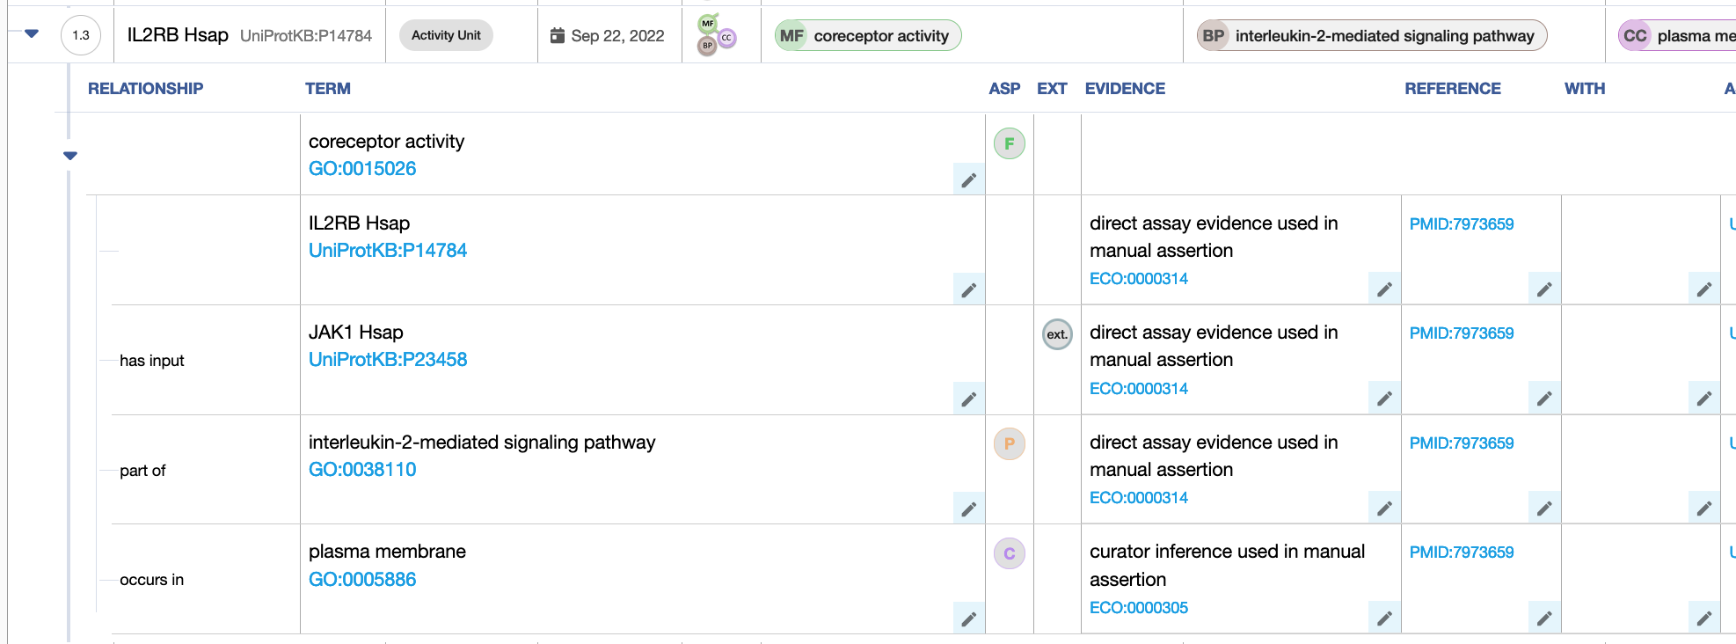

Note:

* cytokine activity is_a receptor ligand activity
* interleukin-2 receptor activity is_a signaling receptor activity

## 

## Differences between GO-CAM and standard annotation of a signaling receptor and its ligand

In standard annotation (captured with the Noctua Form or Protein2GO), relations between molecular functions are not captured, so there is no relation between the ligand activity and the signaling receptor activity, nor is there a relation between the signaling receptor activity and the activity of its target. Likewise for receptor activity and coreceptor activity, there is no relation between these activities captured in standard annotations.

# 

# Review information

Review date: 2023-07-20

Reviewed by: Cristina Casals, Pascale Gaudet, Patrick Masson